CRM APPLICATION THAT HELPS TO BOOK A

VISA SLOT

INTRODUCTION

Overview:

A Visa Slot management project is a system that used to track and manage the availability of visa slot, which are appoints that are required for certain visa applications. It might be used by s government agency or a visa processing centre to schedule and manage appointment with applicants.

PURPOSE

Saving the time of the customers who want to book it by using CRM application of booking a Visa Slot. Wondering for booking the Visa Slot and tracking can be reduce here. Reduce the paper filling as much the customer expecting. Ensuring the safety of the customers and panic of many verification.

2.PROBLEM DEFINITION&DESIGN THINKING

Empathy Map

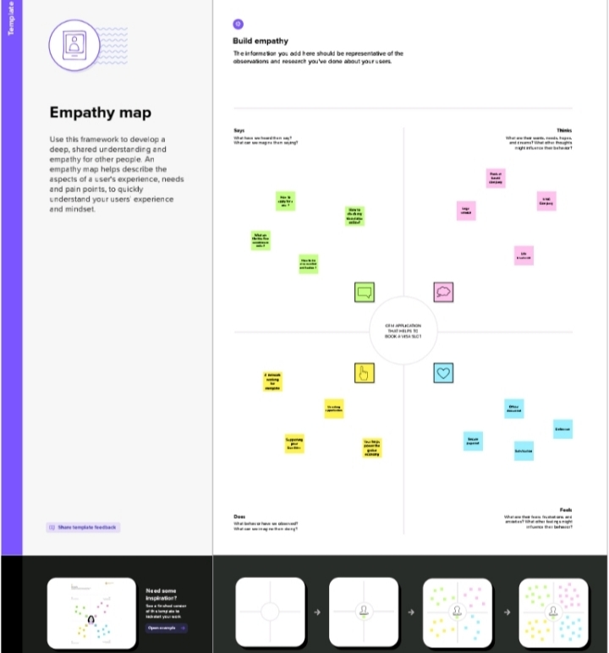

Ideation &Brainstorming Map

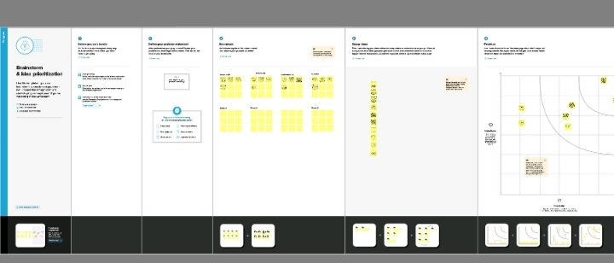

|  |  |  |  |  |
| --- | --- | --- | --- | --- |
| OBJECTS | PASSPORT | VISA  SLOT | PAYMENT | RESCHEDULE/  CANCEL |
| Fields | Full name | Location | Payment Mode | Passport number (Master) |
| Fields | Passport number | Time | Card number | Location |
| Fields | Contact number | Passport number (Master) | Transaction id (Master) | Time |
| Fields | Permanent address | Visa slot number | Cancel transaction | Cancel |
|  |  |  | Visa slot number (Master) | Status |

ACTIVITY&SCREENSHOT

Creating Developer Account

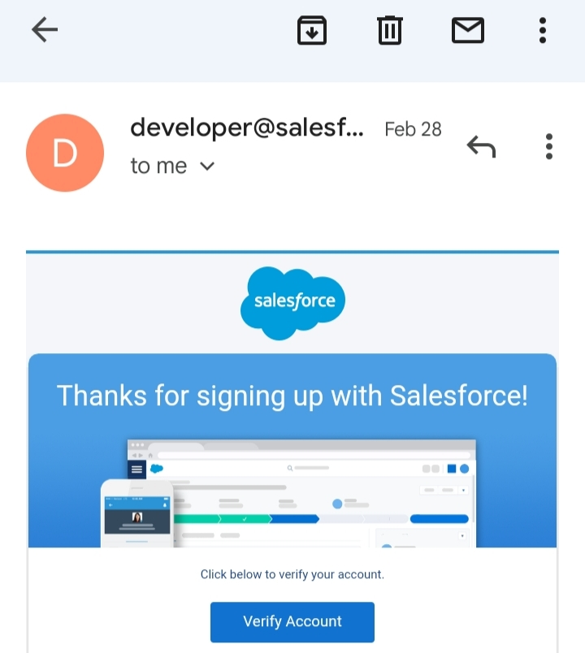

Using this <https://developer.salesforce.com/> link we signup the salesforce platform and finally we get the verification mail that shown in the above figure.

SALESFORCE LOGIN:

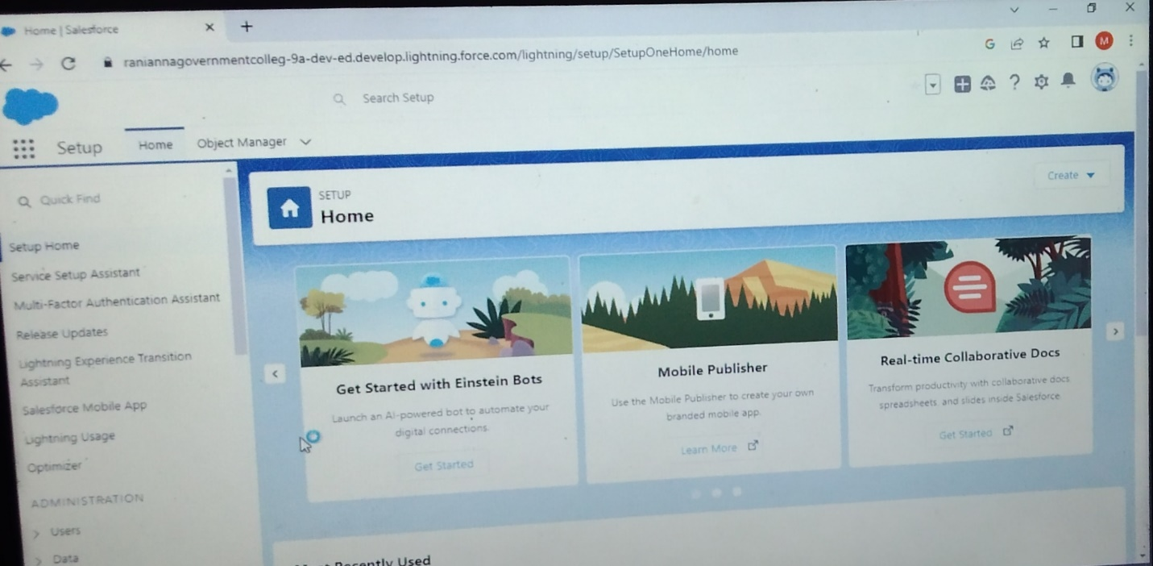

<https://login.salesforce.com/> we used this link to login the salesforce platform. This link asked our username and password only.

OBJECT:

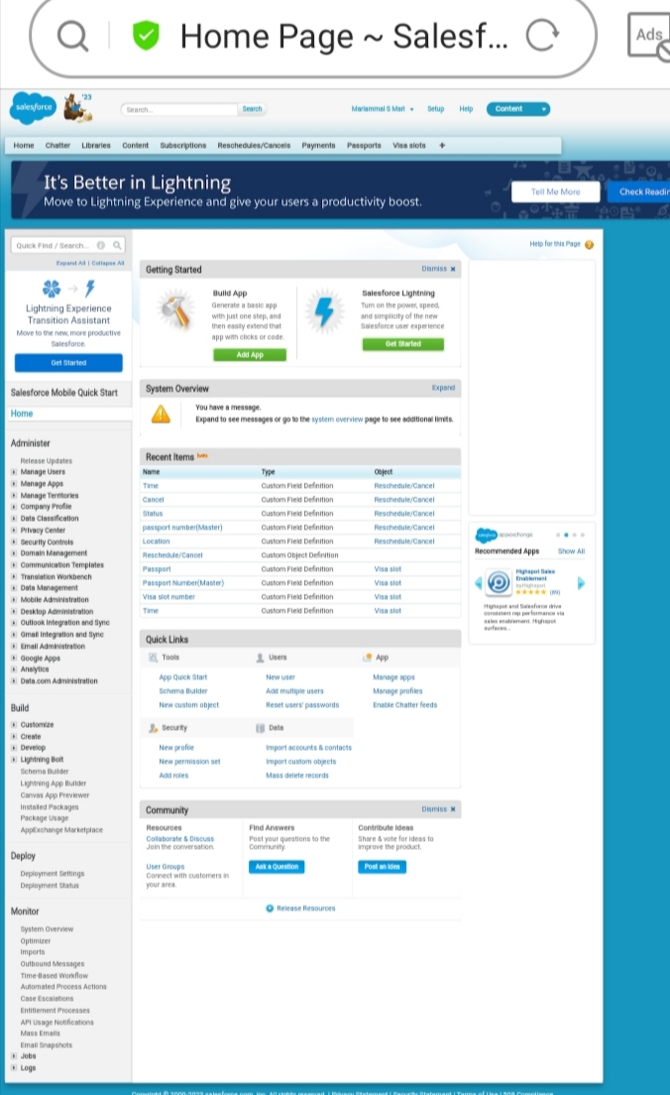

For this visa slot project we create 4 objects. They are Passport, Visa slot, Payment, Reschedule/Cancel.

FIELDS&RELATIONSHIP

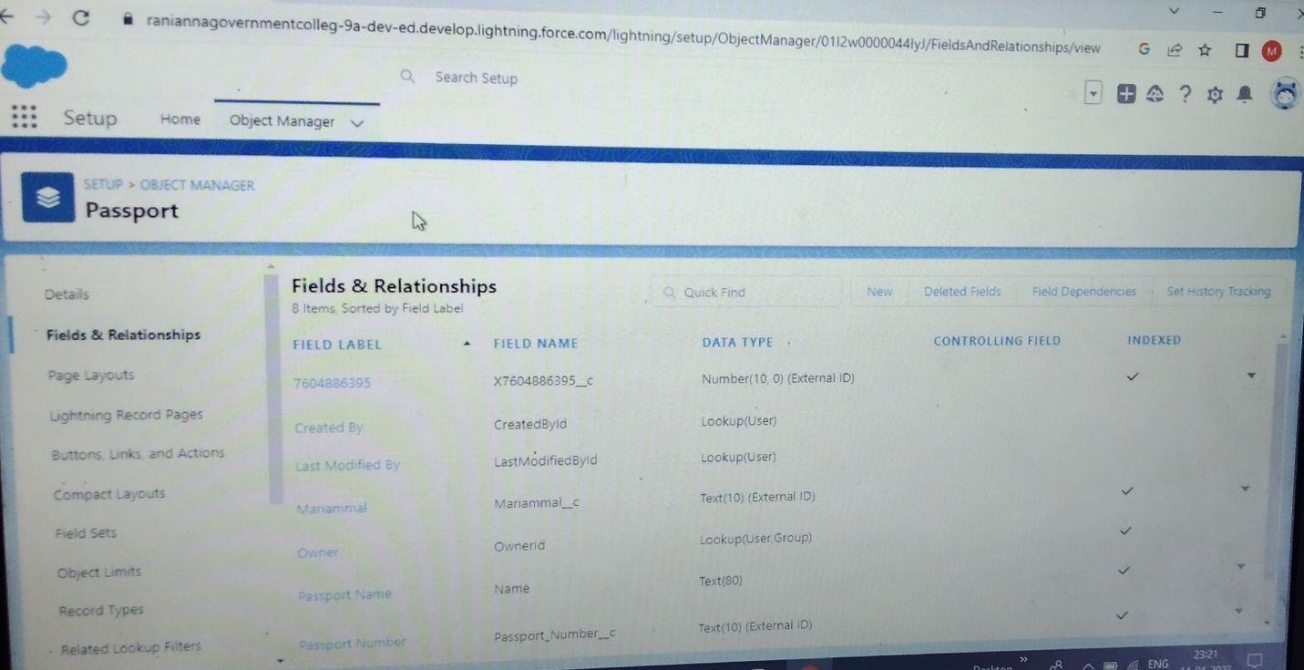

LIGHTENING EXPERIENCE

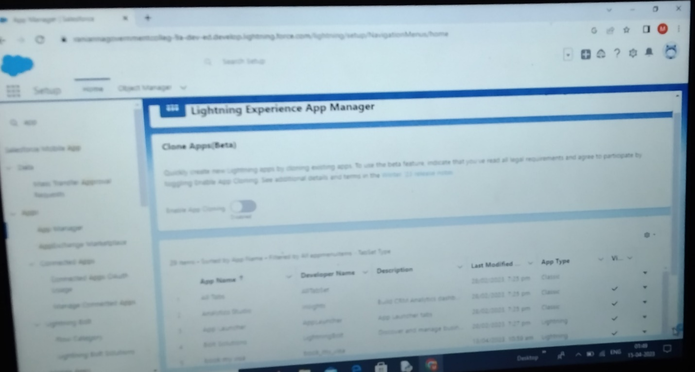

USERS

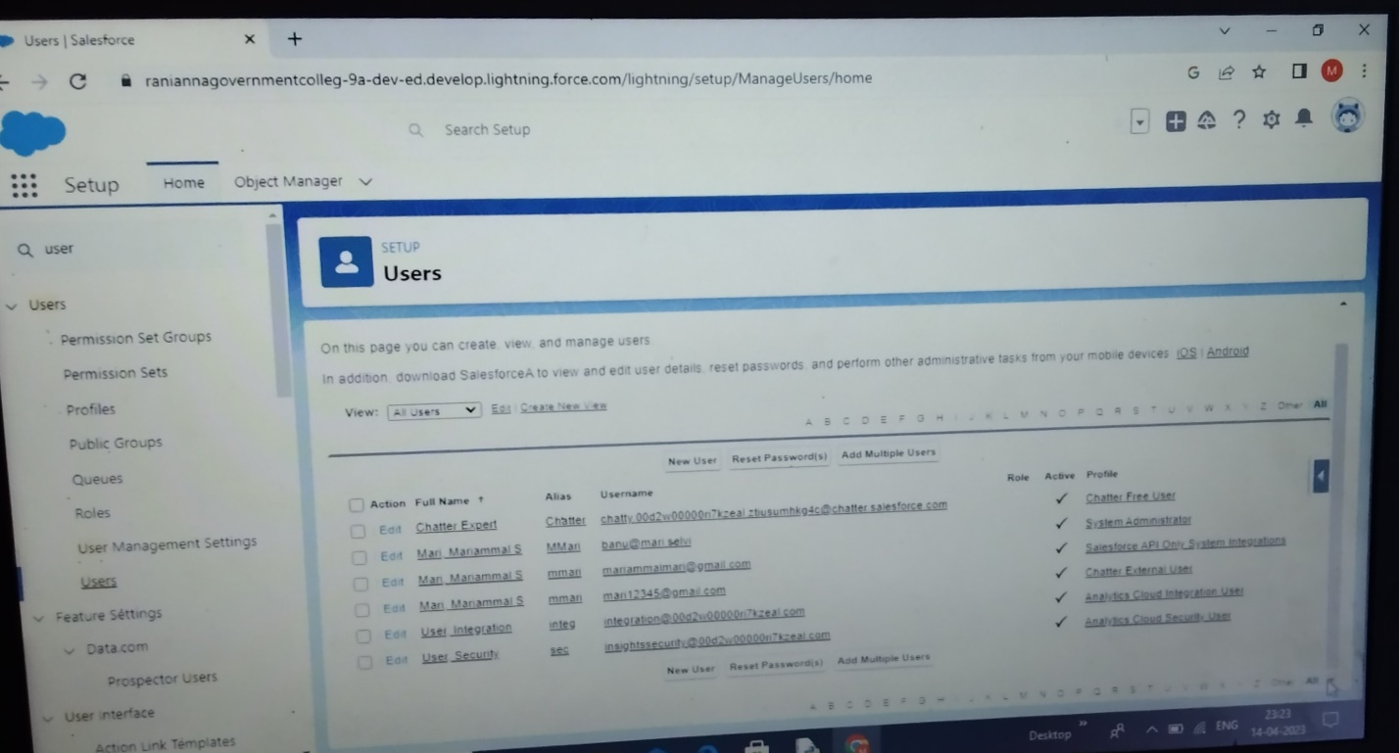

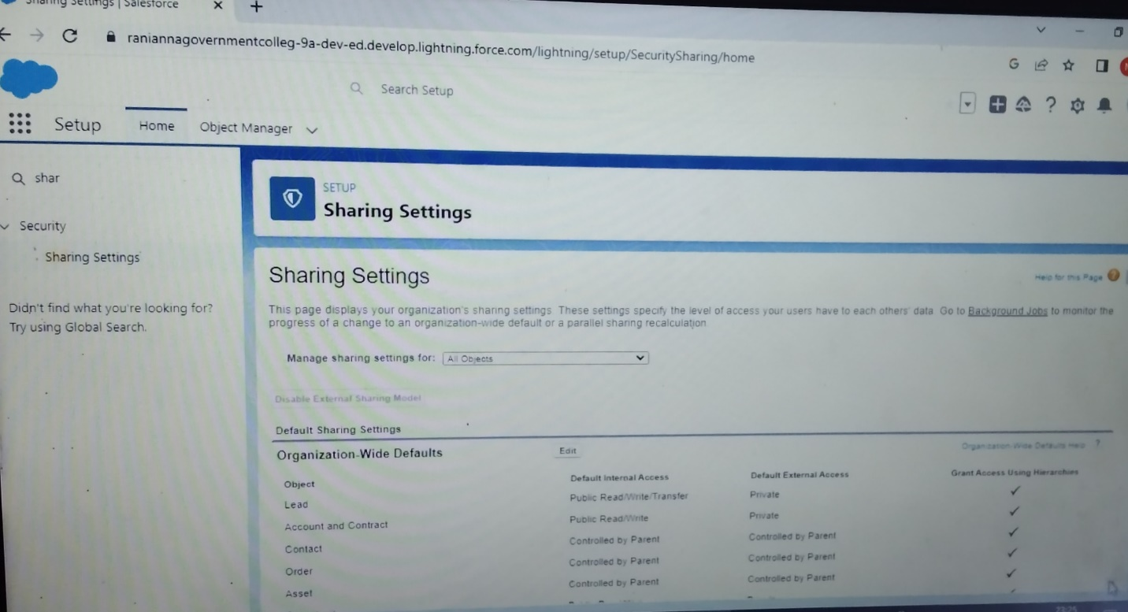

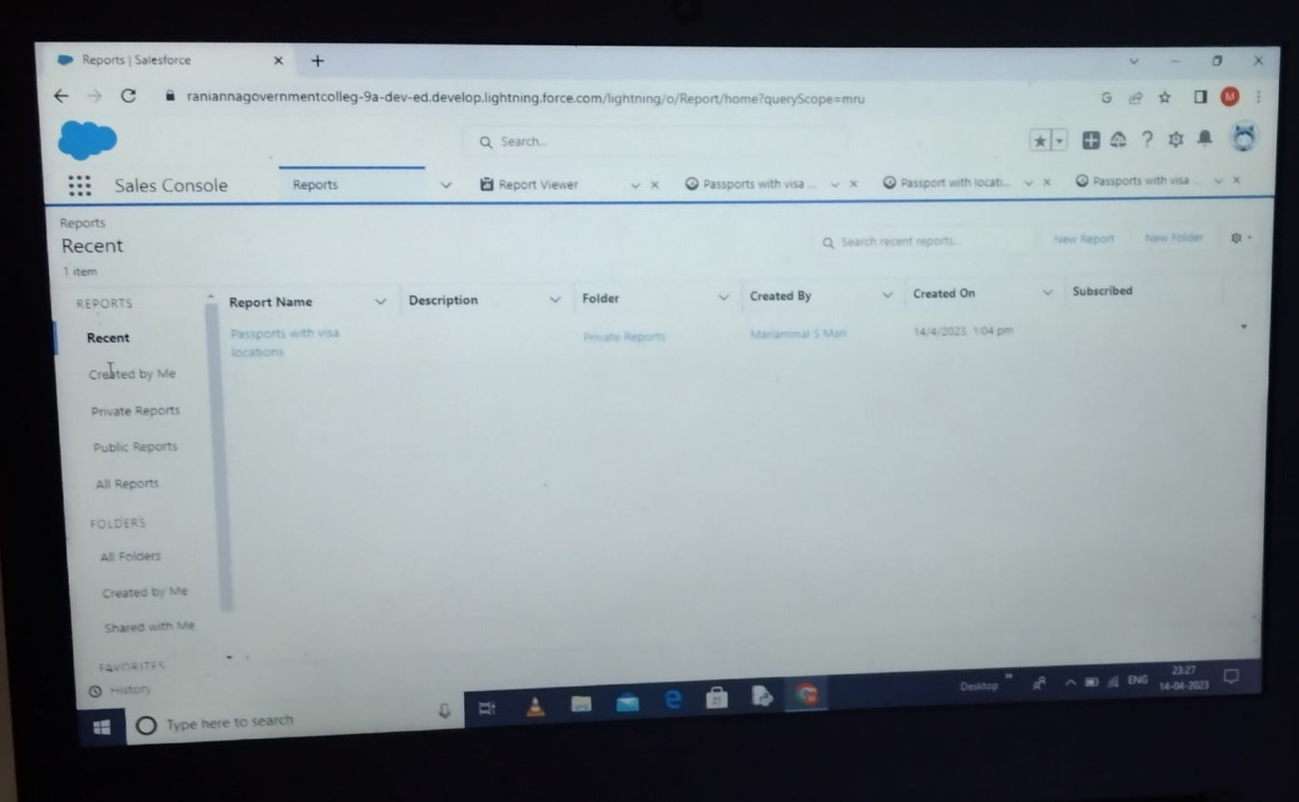

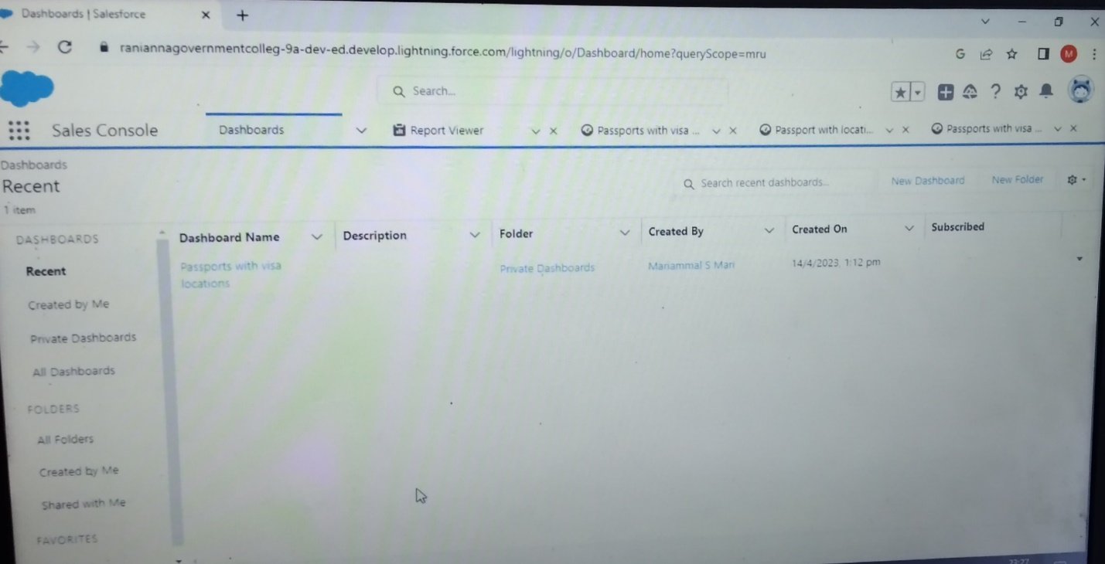

4.TRAILHEAD PROFILE PUBLIC URL

Team Lead - <https://trailblazer.me/id/mmari456>

Team Member 1- <https://trailblazer.me/id/mahek81>

Team Member2- <https://trailblazer.me/id/mmmuthulakshmi>

Team Member3- <https://trailblazer.me/id/sumak28>

ADVANTAGE:

* Having huges amounts of data on customer interactions enables an organisation to build up a clearer picture of its customers.
* A CRM system integrated within a marketing campaign allows insights into the interests of prospective customers.

DISADVANTAGE:

* If staff come to rely too heavily on CRM software, it reduces their flexibility in dealing with customer queries.
* There are risks associated with keeping a lot of data in one place.

CONCLUSION:

A good CRM help you understand your market and the needs of your customers. A CRM saves important data in extensive customer and contact lists.